SKILL / JOB RECOMMENDER APPLICATION

# PROJECT REPORT

***Submitted by***

**SNEKA.L - (612419104021)**

**SEMMALAI PRASATH.P - (612419104019)**

**VIGNESH.V - (612419104023)**

**TEAM ID:**

**[PNT2022TMID41035].**

**Skill /Job Recommender Application**

1. **INTRODUCTION**
   1. Project Overview
   2. Purpose
2. **LITERATURE SURVEY**
   1. Existing problem
   2. References
   3. Problem Statement Definition
3. **IDEATION & PROPOSED SOLUTION**
   1. Empathy Map Canvas
   2. Ideation & Brainstorming
   3. Proposed Solution
   4. Problem Solution Fit
4. **REQUIREMENT ANALYSIS**
   1. Functional Requirements
   2. Non-Functional Requirements
5. **PROJECT DESIGN**
   1. Data Flow Diagrams
   2. Solution & Technical Architecture
   3. User Stories
6. **PROJECT PLANNING & SCHEDULING**
   1. Sprint planning & Estimation
   2. Sprint Delivery Schedule
   3. Reports from JIRA
7. **CODING & SOLUTIONING**
   1. Feature 1
   2. Feature 2

Database Schema (if Applicable)

1. **TESTING**
   1. Test Cases
   2. User Acceptance Testing
2. **RESULTS**
   1. Performance Metrics
3. **ADVANTAGES & DISADVANTAGES**
4. **CONCLUSION**
5. **FUTURE SCOPE**
6. **APPENDIX**

Source code,

Github link & Project Demo link

## INTRODUCTION

Having lots of skills but wondering which job will suit you well? Don’t need to worry! We have come up with a skill recommender solution through which the fresher or the skilled person can log in and find the jobs by using the search option or they can directly interact with the chatbot and get their dream job.

## Project Overview

There has been a sudden boom in the technical industry and an increase in the number of good start-ups. Keeping track of various appropriate job openings in top industry names has become increasingly troublesome. This leads to deadlines and hence important opportunities being missed. Through this research paper, the aim is to automate this process to eliminate this problem. To achieve this, IBM cloud services like db2, Watson assistant, cluster, Kubernetes have been used. A hybrid system of Content-Based Filtering and Collaborative Filtering is implemented to recommend these jobs. The intention is to aggregate and recommend appropriate jobs to job seekers, especially in the engineering domain. The entire process of accessing numerous company websites hoping to find a relevant job opening listed on their career portals is

simplified. The proposed recommendation system is tested on an array of test cases with a fully functioning user interface in the form of a web application. It has shown satisfactory results, outperforming the existing systems.Thus it testifies to the agenda of quality over quantity.

## Purpose

With an increasing number of cash-rich, stable, and promising technical companies/startups on the web which are in much demand right now, many candidates want to apply and work for these companies. They tend to miss out on these postings because there is an ocean of existing systems that list millions of jobs which are generally not relevant at all to the users. There is an abundance of choices and not much streamlining. On the basis of the actual skills or interests of an individual, job seekers often find themselves unable to find the appropriate employment for themselves.Therefore,this system approaches the idea from a data point of view, emphasizing more on the quality of the data than the quantity.

## LITERATURE SURVEY

* 1. **Existing Problem**

Existing system is not very efficient, it does not benefit the user in maximum way, so the proposed system uses ibm cloud services like db2, Watson virtual assistant, cluster, kubernetes and docker for containerization of the application.

* + 1. In this section, we describe our framework for job recommendation. We narrow down the scope and focus on recommendation of job vacancies for Information Technology (IT) professionals acting in the Brazilian market. The proposed framework is composed by three stages: **data collection, data preparation** and **recommendation.**
    2. we select a group of the nearest job offers based on the distance to that profile (job matching). In the case of TF-IDF representation, we use the cosine distance while for word embeddings, we use the relatively new Word Mover’s Distance (WMD) [Kus15]. Once retrieved the top ”k” job offers for the profile, we sort them in descending order based on the inverse of this distance (ranking)
    3. To perform job offers scraping, we created a list of keywords from the IT industry and used them as search terms. For each keyword, we search all the

related job offers using Catho’s search engine and save the retrieved results in our database; thus, the content’s quality is highly related to the quality of the Catho’s search engine.

* + 1. we retrieved data from job search sites using only IT keywords, there were still some job offers that do not correspond to this field, furthermore, the first step in this phase is filtering out job offers that do not belong to the IT field. In order to achieve this, we use a dictionary of weighted IT terms to match each job offer in its document-like format.
    2. Once job offers and profiles are filtered, the second step is text pre- processing. In this task, we perform stop words removal, tokenization and lemmatization for the Portuguese language.
    3. The third step, feature representation, aims to represent these documents (job offers and profiles) as vector space models. For this purpose, we adopted two approaches: word embeddings and TF-IDF. The latter technique does not require so much effort to be implemented unlike the former.

## References

* Shaha T Al-Otaibi and Mourad Ykhlef. “A survey of job recommender systems”.
* In: International Journal of the Physical Sciences 7.29 (2012), pp. 5127–5142. issn: 19921950. doi: 10.5897/IJPS12. 482
* N Deniz, A Noyan, and O G Ertosun. “Linking Person-job Fit to Job Stress: The Mediating Effect of Perceived Person-organization Fit”. In: Procedia - Social and Behavioral Sciences 207 (2015), pp. 369– 376.
* M Diaby, E Viennet, and T Launay. “Toward the next generation of recruitment tools: An online social network-based job recommender system”. In: Proc. of the 2013 IEEE/ACM Int. Conf. on Advances in Social Networks Analysis and Mining, ASONAM 2013 (2013), pp. 821–828. doi: 10. 1145/2492517.2500266.
* M Diaby and E Viennet. “Taxonomy-based job recommender systems on Facebook and LinkedIn profiles”. In: Proc. of Int. Conf. on Research Challenges in Information Science (2014), pp. 1–6. issn: 21511357. doi:

10.1109/RCIS.2014.6861048.

* M Kusner et al. “From word embeddings to document distances”. In: Proc. of the 32nd Int. Conf. on Machine Learning, ICML’15. 2015, pp. 957–966.
* T Mikolov et al. “Distributed Representations of Words and Phrases and Their Compositionality”. In: Proc. of the 26th Int. Conf. on Neural Information Processing Systems - Volume 2. NIPS’13. Lake Tahoe, Nevada, 2013, pp. 3111– 3119. url: [http://dl.acm.org/citation.cfm?id=2999792.](http://dl.acm.org/citation.cfm?id=2999792) 2999959.
* T Mikolov et al. “Efficient estimation of word representations in vector space”. In: arXiv preprint arXiv:1301.3781 (2013).
* G Salton and C Buckley. “Term-weighting approaches in automatic text retrieval”. In: Information Processing and Management 24.5 (1988), pp. 513– 523. issn: 0306-4573. doi: https://doi.org/10. 1016/0306- 4573(88)90021- 0. url: <http://www.sciencedirect.com/science/article/pii/> 030645738890021 PROBLEM

## Problem Statement Definition

"Can an efficient recommender system be modeled for the Job seekers which recommend Jobs with the user’s skill set and job domain and also addresses the issue of cold start?".

In current situation recruitments done manually for lakhs of students in which many talented students may lose their opportunities because of different reasons ever since it is done manually, and company need the highly talented people from the mass group for their growth as well. So we have built a cloud application to do this process in a efficient manner.

## IDEATION AND PROPOSED SOLUTION

* 1. **Empathy Map Canvas**

An empathy map is a collaborative visualization used to articulate what we know about a particular type of user. It externalizes knowledge about users in order to

1. Create a shared understanding of user needs, and
2. Aid in decision making

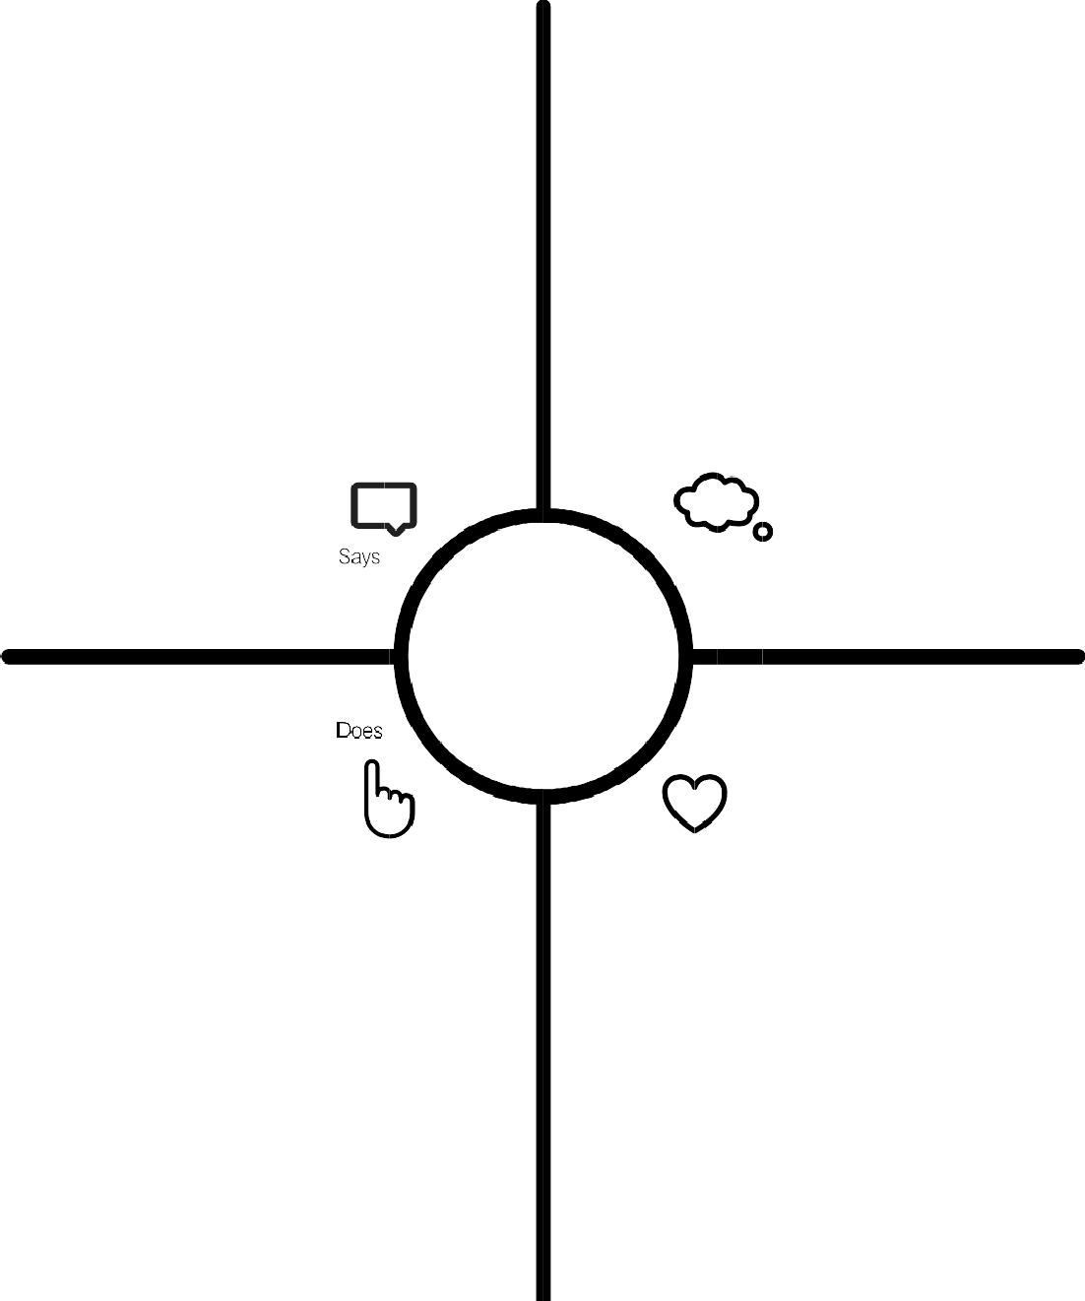

**Skills / Job**

**Recommender**

**Conflict Resolution**

**Job Opportunities**

**Chatbot for job recommendation**

**Job Search API**

**Working Time**

**Job Satisfaction**

**Company Location and information**

**Job recommended**

**Digital Communication**

**Skills Analysis**

**Job Description**

**Time Management**

**Skills in Resume**

## Ideation & Brainstorming

Brainstorm & Idea Prioritization Template: Brainstorming provides a free and open environment that encourages everyone within a team to participate in the creative thinking process that leads to problem solving. Prioritizing volume over value, out-of-the-box ideas are welcome and built upon, and all participants are encouraged to collaborate, helping each other develop a rich amount of creative solutions. Use this template in your own brainstorming sessions so your team can unleash their imagination and start shaping concepts even if you're not sitting in the same room.

**Step 1: Team Gathering, Collaboration and Select the Problem Statement**

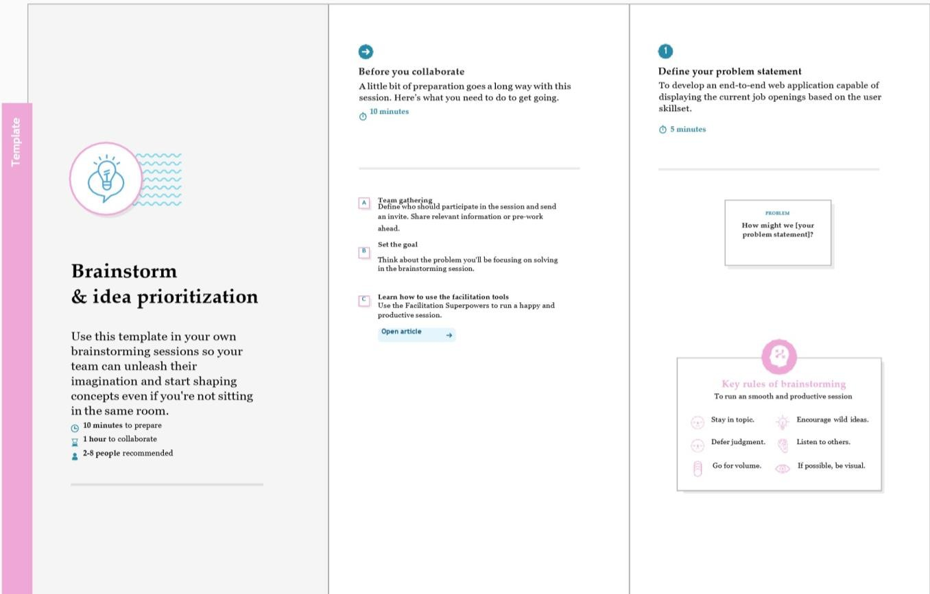

**Step 2: Brainstorm, Idea Listing and Grouping**

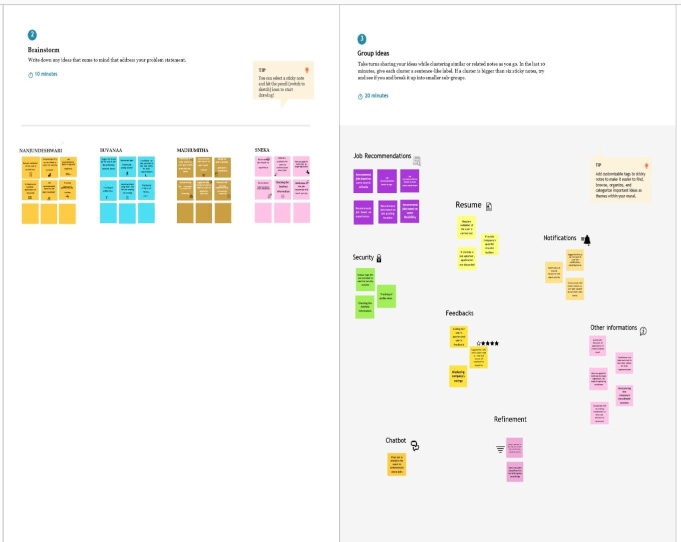

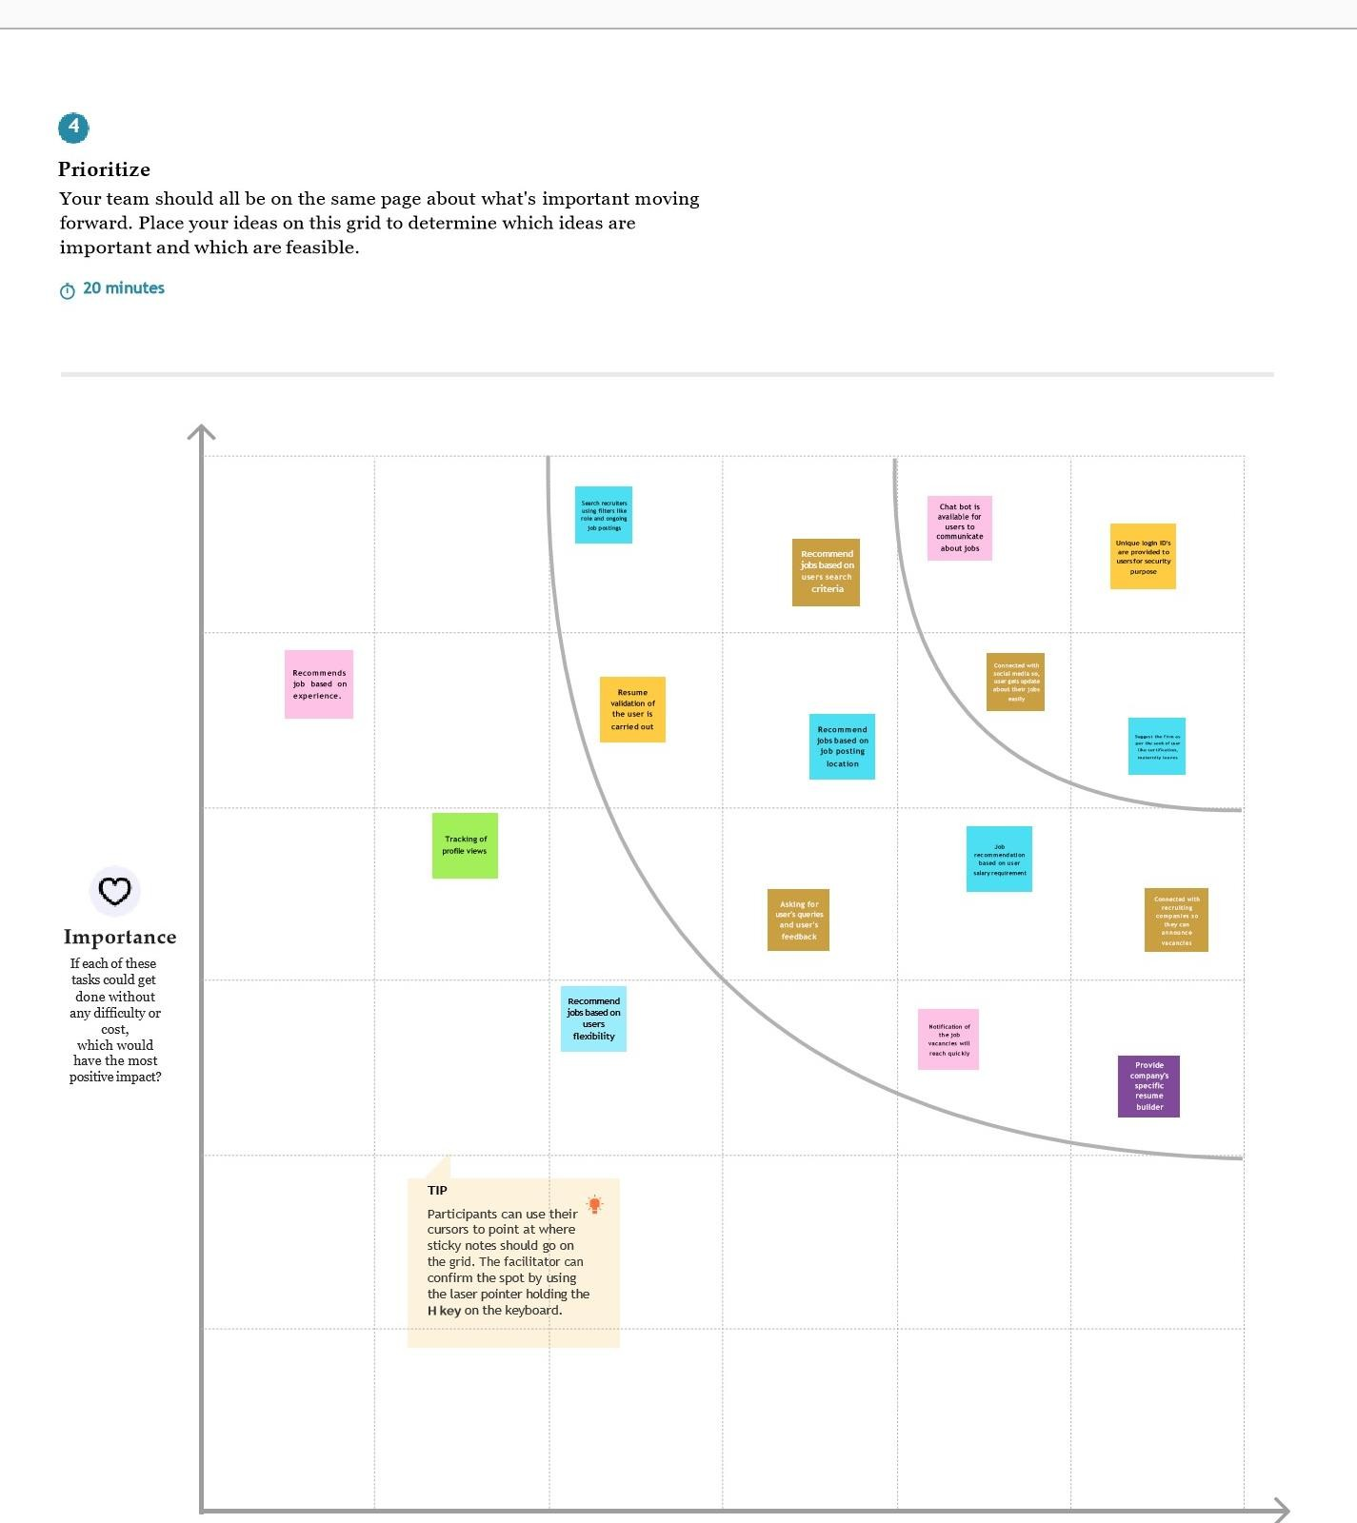**Step 3: Idea Prioritization**

## Proposed Solution

Having lots of skills but wondering which job will best suit you? Don’t need to worry! We have come up with a skill recommender solution through which the fresher or the skilled person can log in and find the jobs by using the search option or they can directly interact with the chatbot and get their dream job.

To develop an end-to-end web application capable of displaying the current job openings based on the user skillset. The user and their information are stored in the Database. An alert is sent when there is an opening based on the user skillset. Users will interact with the chatbot and can get the recommendations based on their skills. We can use a job search API to get the current job openings in the market which will fetch the data directly from the webpage

## Problem Solution Fit

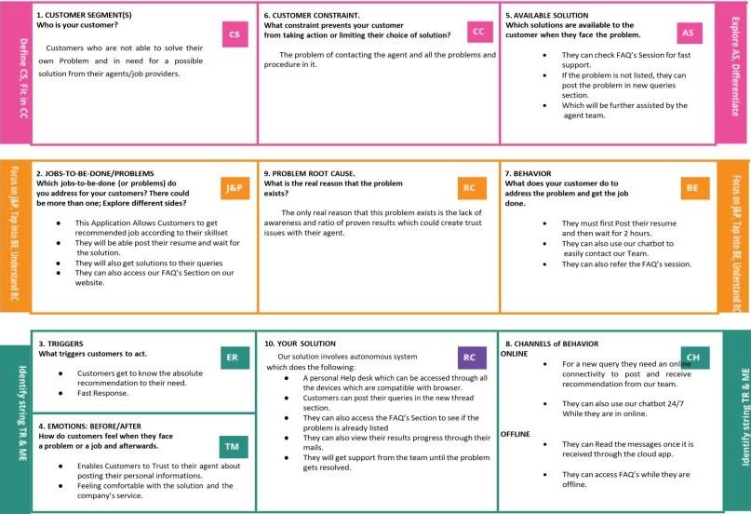

1. **REQUIREMENT ANALYSIS**

## Functional Requirements:

Following are the functional requirements of the proposed solution.

|  |  |  |
| --- | --- | --- |
| FR No. | Functional Requirement (Epic) | Sub Requirement (Story / Sub-Task) |
| FR-1 | User Registration | Registration through Form.  Registration through Gmail. Registration through Application. |
| FR-2 | User Confirmation | Confirmation via Email. Confirmation viaOTP. |
| FR-3 | User Login | Login using credentials. |
| FR-4 | User Application | Search for desired company. |
| FR-5 | User Profile | Complete user profile by providing personal details. |
| FR-6 | User Application | User applies for the desired company. |

## Non-functional requirements:

Following are the non-functional requirements of the proposed solution.

|  |  |  |
| --- | --- | --- |
| **FR No.** | **Non-Functional Requirement** | **Description** |
| NFR-1 | Usability | * User-Friendly Application. |
| NFR-2 | Security | * End-to-End Encryption. |
| NFR-3 | Reliability | * Based on personalised skill sets. |
| NFR-4 | Performance | * Analysing the skill sets of the user to ensure our recommendations reach them better. |
| NFR-5 | Availability | * 24/7 chatbot support✓ 24/7 chatbot support. |
| NFR-6 | Scalability | * Reaching the on-scale requirement of the user. |

## PROJECT DESIGN

* 1. **Data flow diagrams:**

A Data Flow Diagram (DFD) is a traditional visual representation of the information flows within a system. A neat and clear DFD can depict the rightamount of the system requirement graphically. It shows how data enters and leaves the system, what changes the information, and where data is stored.

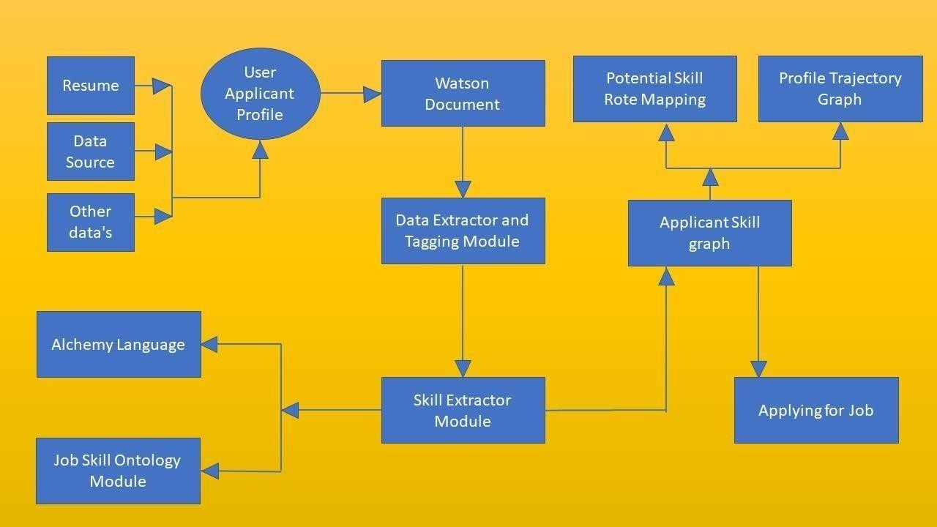

## Solution Technology Architecture:

The deliverable shall include the architectural diagram as below

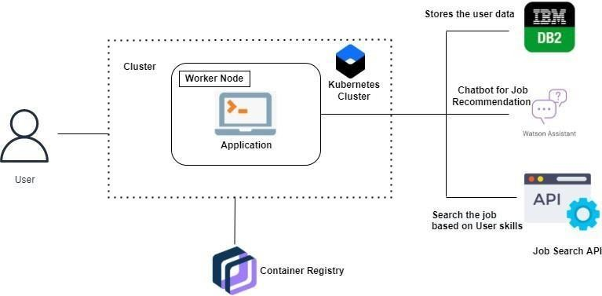

|  |  |  |  |
| --- | --- | --- | --- |
|  |  |  |  |
| 1. | User Interface | How user interacts with application e.g. Web UI, Mobile App, Chatbot etc. | HTML, CSS, JavaScript / Angular Js  /ReactJ setc. |
| 2. | Developing Interface | Developing application for the task | Java /Python |
| 3. | Voice Assistance | Voice commands instead of typing. | IBM Watson STT service |
| 4. | Chatbot Assistance | Conversational Interface | IBM Watson Assistant |
| 5. | Database | Data Type, Configurations etc. | MySQL, NoSQL, etc. |
| 6. | Cloud Database | Database Service on Cloud | IBMDB2, IBM Cloudant etc. |
| 7. | File Storage | File storage requirements | IBM Block Storage or Other Storage Service or Local File system |
| 8. | Machine Learning Model | Purpose of Machine Learning Model | Object Recognition Model, etc. |
| 9. | Infrastructure (Server/Cloud) | Application Deployment on Local System  /Cloud Local Server Configuration: Cloud Server  Configuration: | Local, Cloud Foundry, Kubernetes, etc. |

## User Stories

Use the below template to list all the user stories for the product.

|  |  |  |  |  |  |  |
| --- | --- | --- | --- | --- | --- | --- |
| **User Type** | **Functio nal Requir ement** | **User Story Num ber** | **User Story / Task** | **Acceptance criteria** | **Priorit y** | **Release** |
| Customer (Mobile user) | Registration | USN-1 | As a user, I can register for the application by  entering my email, password, and confirming my password. | I can access my account / dashboard | High | Sprint- 1 |
|  |  | USN-2 | As a user, I will receive confirmation email  once I have registered for the application | I can receive confirmation  email & click confirm | High | Sprint- 1 |
|  |  | USN-3 | As a user, I can register for the application through Facebook | I can register & access the dashboard with Facebook  Login | Low | Sprint- 2 |
|  |  | USN-4 | As a user, I can register for the application through Gmail | I can receive confirmation  email & click confirm | Mediu m | Sprint- 1 |
|  | Login | USN-5 | As a user, I can log into the application by entering email & password | I can access my account / dashboard | High | Sprint- 1 |
|  | Dashboard | USN-6 | Create a model set that contains those models, then assign it to a role. | Assign that group to the appropriate  roles on the Roles page. | High | Sprint- 1 |
| Customer (Web user) | [Identity-](https://console.cloud.google.com/security/iap) [Aware](https://console.cloud.google.com/security/iap) | USN-7 | Open, public access, User-authenticated access, Employee- restricted access. | Company public website. App running on the company intranet. App with access to customer private  information. | High | Sprint- 1 |

|  |  |  |  |  |  |  |
| --- | --- | --- | --- | --- | --- | --- |
| Customer Care Executive | Communicati on | USN-8 | A customer care executive is a professional responsible for communicating the how's and  why's regarding service  expectations within a company. | For how to tackle customer queries. | Mediu m | Sprint- 1 |
| Administrat or | Device manage ment | USN-9 | You can  Delete/Disable/Enable devices inAzure Active Directory but you cannot  Add/Remove Users in the directory. | Ease of use. | Mediu m | Sprint- 1 |

## PROJECT PLANNING AND SCHEDULING

* 1. **Sprint Planning and Exatimation**

|  |  |
| --- | --- |
| Title | Description |
| Literature Survey and Information Gathering | Gathering Information by referring the technical papers, research publications etc |
| Prepare Empathy Map | To capture user pain and gains Prepare List of Problem Statement |
| Ideation | Prioritise a top 3 ideas based on feasibility and Importance |
| Proposed Solution | Solution include novelty, feasibility, business model, social impact and scalability of solution |
| Problem Solution Fit | Solution fit document |
| Solution Architecture | Solution Architecture |
| Customer Journey | To Understand User |

|  |  |
| --- | --- |
|  | Interactions and experiences with application |
| Functional Requirement | Prepare functional Requirement |
| Data flow Diagrams | Data flow diagram |
| Technology Architecture | Technology Architecture diagram |
| Milestone & sprint delivery plan | Activity what we done & further plans |
| Project Development Delivery of sprint 1,2,3 & 4 | Develop and submit the developed code by testing it |

* 1. **Sprint delivery schedule**

|  |  |  |
| --- | --- | --- |
| SPRINT | TASK | MEMBERS |
| SPRINT 1 | Create Registration page , login page , Job search portal , job apply portal in flask | Sneak.L  Semmalai passath.P  Vignesh.v |
| SPRINT 2 | Connect application to ibm db2 | Sneak.L  Semmalai passath.P  Vignesh.V |
| SPRINT 3 | Integrate ibm Watson assisstant | Sneak.L  Semmalai passath.P  Vignesh.V |
| SPRINT 4 | Containerize the app and deploy the application in ibm cloud | Sneak.L  Semmalai passath.P  Vignesh.V |

## Reports from JIRA:

Average Age Report.

Created vs Resolved Issues Report. Pie Chart Report.

Recently Created Issues Report. Resolution Time Report.

Single Level Group by Report. Time Since Issues Report.

Time Tracking Report.

# CODING & SOLUTIONING

Feature 1:

**App Market**

This is one of the feature of our application which provides companies job details for end users

<!Doctype html>

<html>

<head>

<title>MSBN JOB PORTAL</title>

</head>

<style>

body{

background-image: url("https://gowmi12.s3.jp-tok.cloud-object- storage.appdomain.cloud/search%20(2).jpeg");

}

h1{

color: antiquewhite; font-size: 4pc;

}

h2{

font-size: 2pc; color: #04AA6D; }

a {

text-decoration: none; display: inline-block; padding: 8px 16px;

}

a:hover {

background-color: #ddd; color: black;

}

.previous {

background-color: #f1f1f1; color: black;

}

.next {

background-color: #e01010; color: white;

}

</style>

<body>

<h1>Welcome </h1>

<h2> &nbsp; &nbsp;&nbsp;&nbsp; We are glad to</h2>

<h2> Introduce our MSBN </h2>

<h2>&nbsp;&nbsp;&nbsp;&nbsp; &nbsp; &nbsp; Portal!</h2>

<pre> <a href="https://gowmi12.s3.jp-tok.cloud-object- storage.appdomain.cloud/login%20and%20%20signup%20pg%20.html" class="next">Start &raquo;</a></pre>

</body>

</html>

Feature 2:

**ChatBot (using IBM Watson)**

This chat bot feature provides help tooltip for end users if any help needed forusers

<script>

window.watsonAssistantChatOptions = {

integrationID: "9be41b76-06b0-426f-8469-962f2963cdb6", // The ID of this integration. region: "au-syd", // The region your integration is hosted in.

serviceInstanceID: "76838ca2-a227-4f56-b180-94f01901cdbf", // The ID of your service instance.onLoad: function(instance) { instance.render(); }

};

setTimeout(function(){

const t=document.createElement('script');

t.src="https://web-chat.global.assistant.watson.appdomain.cloud/versions/" + (window.watsonAssistantChatOptions.clientVersion || 'latest') + "/WatsonAssistantChatEntry.js";

document.head.appendChild(t);

});

</script>

1. **TESTING**

**Test Cases:**

We tested for various validations. Tested all the features with using all the functionalities. Tested the data base storage and retrieval feature too.

Testing was done in phase 1 and phase 2, where issues found in phase1 werefixed and then tested again in phase2.

## User Acceptance Testing:

Real world testing was also done, by giving to remote users and asking them touse the application. Their difficulties were fixed and tested again until all the issues were fixed.

## RESULTS

**HOME PAGE**



**LOGIN PAGE**

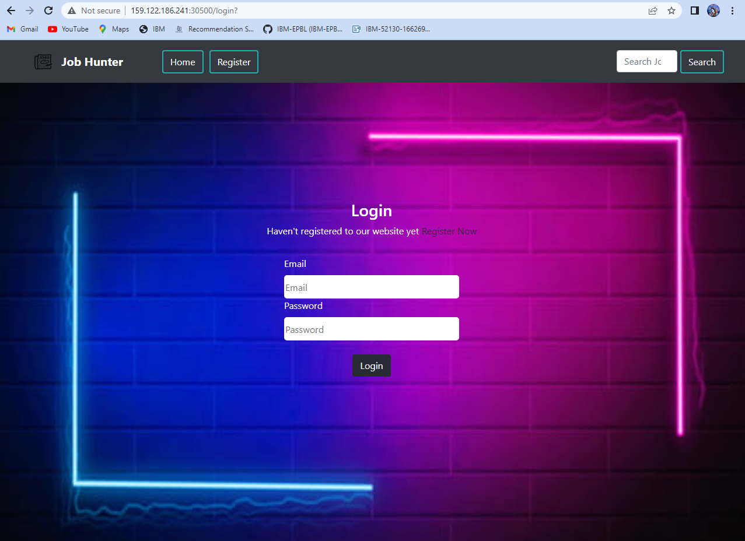

**REGISTER PAGE**

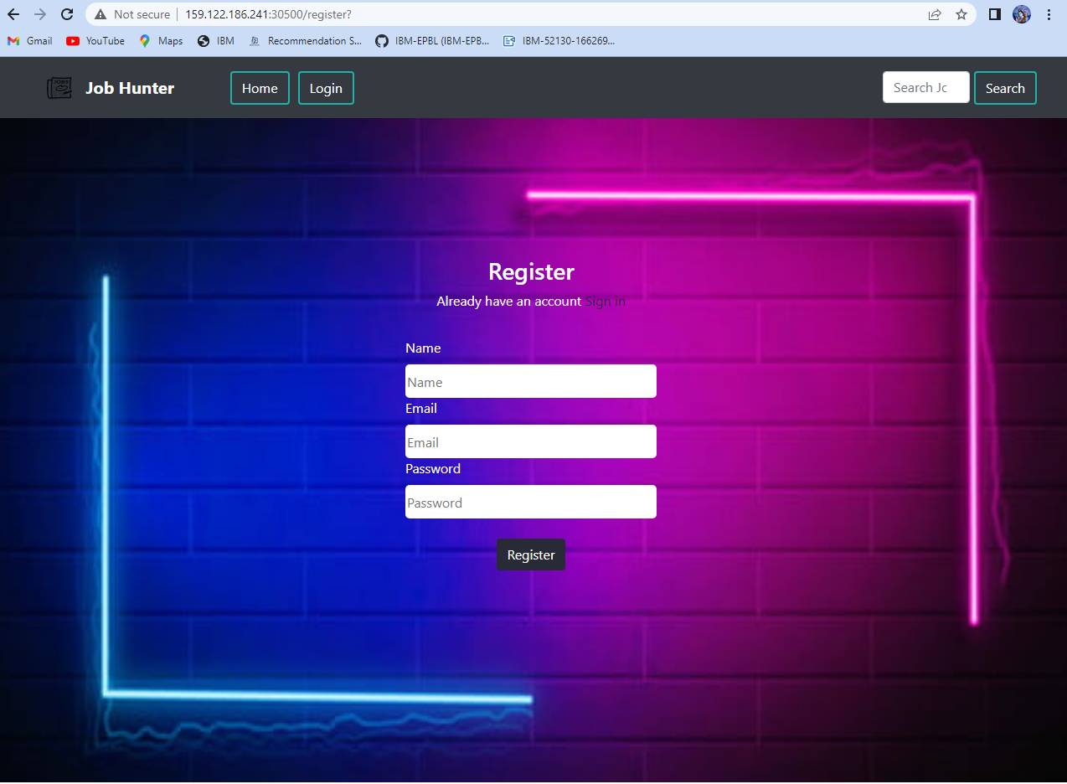

**APPLICATION DETAILS PAGE**

,L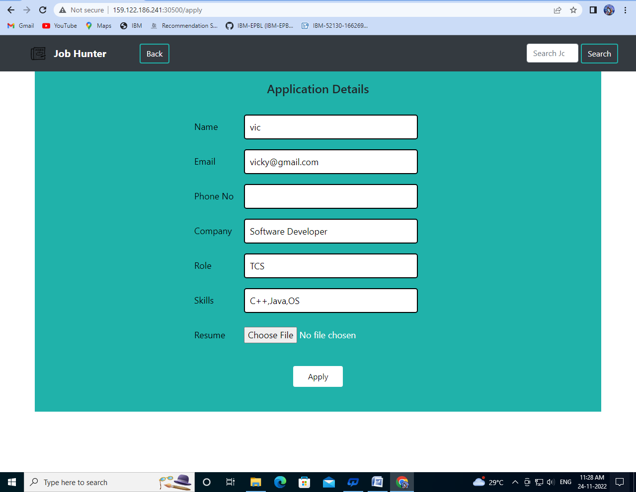

**JOB SEARCH**



VIRTUAL ASSISTANT PAGE

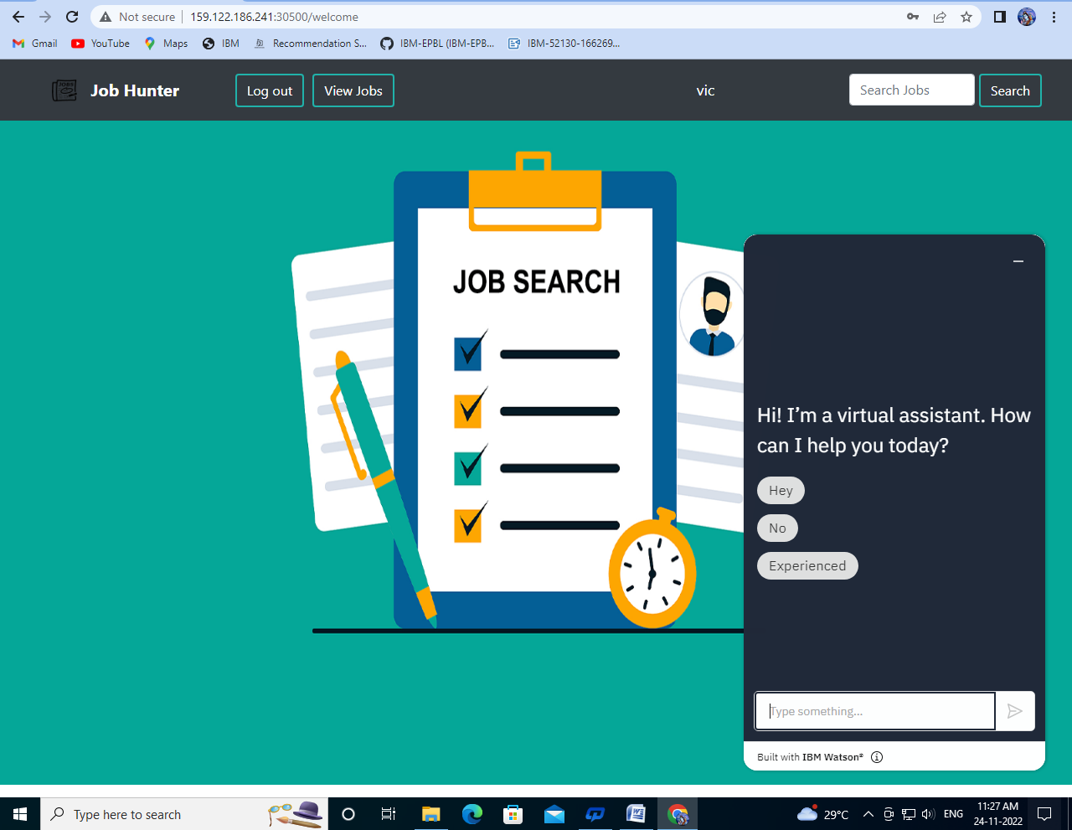

**JOB MENU**

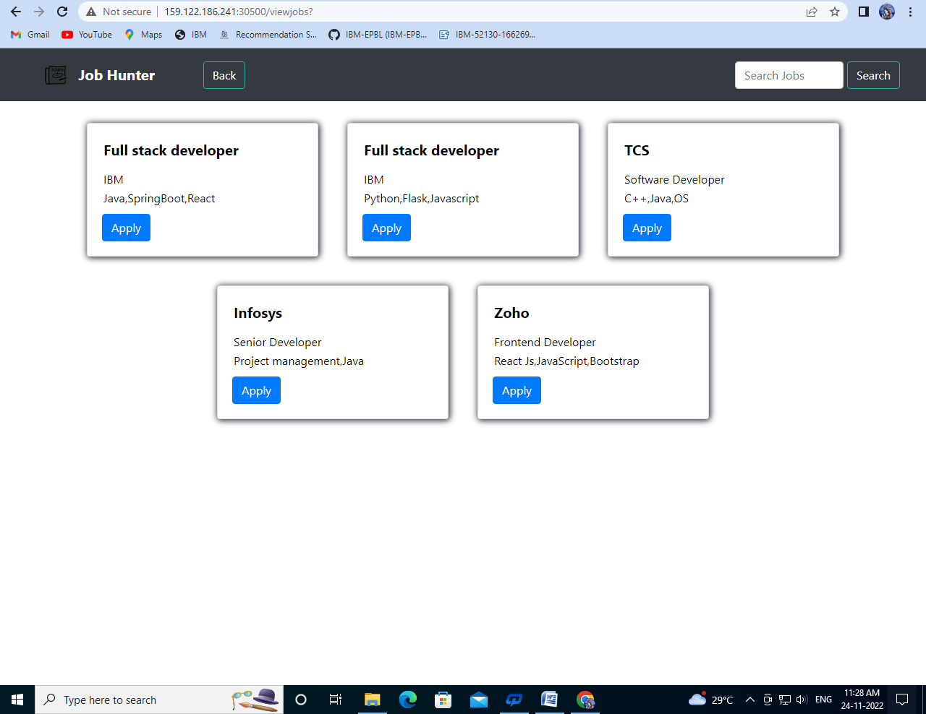

1. **ADVANTAGES AND DISAVANTAGES**

**ADVANTAGE :**

* It helps candidates to search the job which perfectly suites them and make them aware of all the job openings.
* It help recruiters of the company to choose the right candidates for their organizations with appropriate skills.
* Since it is cloud application, it does require any installation of software and is portable.

**DISADVANTAGE:**

* It is costly.
* Uninterrupted internet connection is required for smooth functioning of application

## CONCLUSION

we have used ibm cloud services like db2, cloud registry, kubernetes , Watson assistant to create this application , which will be very useful for candidates who are searching for job and as well as for the company to select the right candidate for their organization.

## FUTURE SCOPE

Future directions of our work will focus on performing a more exhaustive evaluation considering a greater amount of methods and data as well as a comprehensive evaluation of the impact of each professional skill of a job seeker on the received job recommendation. We can use machine learning techniquesto recommend data in a efficient way.

## APPENDIX

SOURCE CODE

<!Doctype html>

<html>

<head>

<title>MSBN JOB PORTAL</title>

</head>

<style>

body{

background-image: url("https://gowmi12.s3.jp-tok.cloud-object- storage.appdomain.cloud/search%20(2).jpeg");

}

h1{

color: antiquewhite; font-size: 4pc;

}

h2{

font-size: 2pc; color: #04AA6D; }

a {

text-decoration: none;

display: inline-block; padding: 8px 16px;

}

a:hover {

background-color: #ddd; color: black;

}

.previous {

background-color: #f1f1f1; color: black;

}

.next {

background-color: #e01010; color: white;

}

</style>

<body>

<h1>Welcome </h1>

<h2> &nbsp; &nbsp;&nbsp;&nbsp; We are glad to</h2>

<h2> Introduce our MSBN </h2>

<h2>&nbsp;&nbsp;&nbsp;&nbsp; &nbsp; &nbsp; Portal!</h2>

<pre> <a href="https://gowmi12.s3.jp-tok.cloud-object- storage.appdomain.cloud/login%20and%20%20signup%20pg%20.html" class="next">Start &raquo;</a></pre>

</body>

</html>

**Github Link**

<https://github.com/IBM-EPBL/IBM-Project-52130-1660989612>